Name: Cicelia Siu

CS 219.1001 – Assignment #1

Purpose: Become familiar with basic architecture and computer abstractions (Chapter 1)

Due: Wednesday (1/27)

Points: 100

Reading:

Chapter 1, Chapter 4

Assignment:

1) Based on lecture and the text, what are the classes of computing applications (five)? Provide a one sentence description of each. [5pts]

**Personal Computers** are designed for single user, aka desktops and laptops

**Servers** are a computer programs that run for multiple users/computer, accessed by network.

**Supercomputers** are extremely powerful, high level computers.

**Embedded Computers** are computers, usually in everyday appliances, and run one predetermined application or collection of software.

**Mobile Computing** are your mobile devices(iPhone or Android) that allow access to data over a network and rely on battery.

2) Name five devices with embedded computers that you have used? [5 pts]

Microwave, TV, washing machine, dishwashers, and air conditioners.

3) According to the class text, what are the five classic components of a computer? [5 pts]

input, output, memory, processor, and datapath

4) What is an Instruction Set Architecture (ISA)? [3 pts]

ISA: an abstract interface between the hardware and the lowest-level software that encompasses all the information necessary to write a machine language program that will run correctly, including instructions, registers, memory access, I/O, and so on

5) Define each of the following terms: [2 pts each]

a) volatile memory : Storage that retains data only when getting power

b) non-volatile memory : storage that retains data even when getting no power

c) main/primary memory : volatile memory used to hold programs while they are running

d) secondary memory : nonvolatile memory used to store programs and data between runs

6) Define the following terms: [2 pts each]

a) response time : total time required for the computer to complete a task

b) throughput : measure of performance, number of tasks completed per unit time.

7) Explain the impact on throughput and response time for each of the following changes in a computer system: [3 pts each]

a) Replacing the processor in a computer with a faster version

Both response times and throughput are improved.

b) Adding additional processors to a system that uses multiple processors for separate tasks – for example, searching the web.

Only throughput increases, and possibly improve response times.

8) What are the hardware/software components affecting program performance (four)? [4 pts]

Algorithm - affects instruction count and possibly CPI

Programming Language - affects instruction count and CPI

Compiler - affects instruction count amd CPI

Instruction Set Architecture - affects, instruction count, clock rate and CPI

9) For a color display using 10-bits for each of the primary colors (red, green, blue) per pixel and with a resolution of 1280 x 800 pixels, what should be the size (in bytes) of the frame buffer to store a single, complete frame? [5 pts]

1290x800 pixels = 1,024,000 pixels

10 bits x 3 colors = 30 bits per pixel (closest is int which is 32 bits so use 32)

1,024,000 pixels x 32 bits per pixel = 32,768,000 bits

32,768,000 bits x (1 byte / 8 bits) = **4,096,000 bytes**

10) If a computer connected to a 1 gigabit Ethernet network needs to send a 256 Kbytes file, how long would it take? [5 pts]

1 gigabit network = 125 Mbyte per second = 125,000 Kbyte per second

256 Kbyte *(1 sec / 125,000 Kbyte) = .**00205 seconds or 2.05 ms**

11) Assuming that cache memory is ten times faster than DRAM memory, that DRAM memory is 100,000 times faster than magnetic disk, and that flash memory is 1000 times faster than disk, find out how long it takes to read a file from a DRAM, a disk, and a flash memory if it takes 2 microseconds from the cache memory? [5 pts]

cache memory = 2 microseconds

cache *10 = DRAM

2 * 10= DRAM

**DRAM = 20 microseconds**

DRAM *100,000 = magnetic disk

20*100,000 = magnetic disk

**Magnetic disk = 2,000,000 microseconds or 2 seconds**

Flash *1,000 = disk

Flash = 2,000,000 microseconds/1,000

**Flash = 2,000 microseconds**

12) Consider three different processors P1, P2, and P3 executing the same instruction set with clock rates and CPI's given in the following table. Must show calculations for credit.

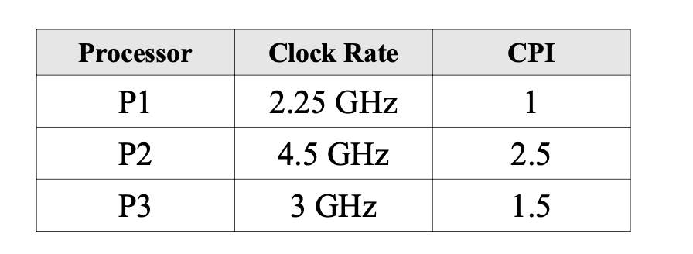

a) Which processor has the highest performance? [5 pts]

CPU exec time = cpu clock cycle/ clock rate

P1 = (2.25*10^9) / 1 = 2.25*10^9

P2 = (4.45*10^9) / 2.5 = 1.8*10^9

P3 = (3.0*10^9) / 1.5 = 2.0*10^9

**P1 has the highest performance (with the slowest clock)**

b) If the processors each execute a program in 10 seconds, find (a) the number of cycles and (b) the number of instructions for each. [5 pts]

1. CPU exec time = cpu clock cycle/ clock rate

given execution time ( 10 seconds) and clock rate

Program cycles = time * clock rate

P1 = 10 sec * (2.25*10^9 cycles/sec) = 22.5*10^9 cycles

P2 = 10 sec * (4.45*10^9 cycles/sec) =44.5*10^9 cycles

P3 = 10 sec * (3*10^9 cycles/sec) = 30.0*10^9 cycles

1. time = (instructions * CPI) / clock rate

given time, clock rate, cpi find instructions

instructions = (time *clock rate) / CPI

Time*clock rate done in (a)

P1 = (22.5*10^9)/ 1.0 = 22.5*10^9 instructions

P2 = (44.5*10^9) / 2.5 = 18*10^9 instructions

P3 = (30.0*10^9) / 1.5 = 20*10^9 instructions

13) Use the following information for the questions below. Must show calculations for credit.

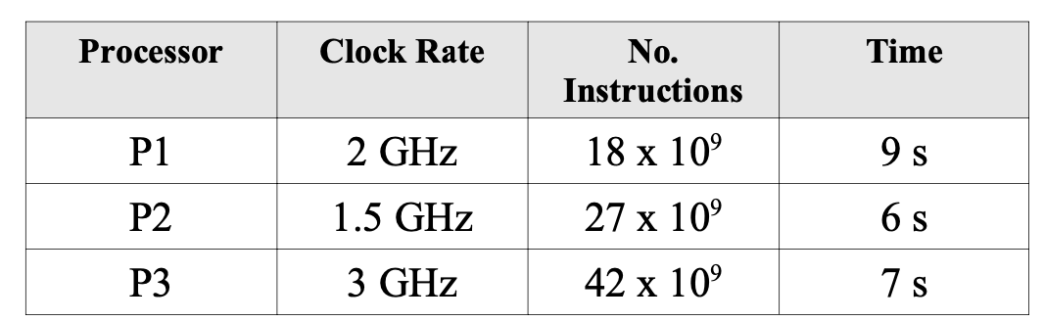

a) Find the IPC (instructions per cycle) for each processor. [5 pts]

IPC = 1/CPI

CPI = (time * clock rate)/ instructions

so IPC = instructions / (time * clock rate)

P1 = (18*109) / (9 * (2*109 cycles per sec)) = 1 instruction per cycle

P2 = (27*109) / (6* (1.5*109 cycles per sec)) = 3 instructions per cycle

P3 = (42*109) / (7* (3*109 cycles per sec)) = 2 instructions per cycle

b) Which processor has the highest performance? [5 pts]

**P2 has the highest performance with 3 instructions per cycle.**

14) Consider two different implementations of the same instruction set architecture. There are four classes of instructions A, B, C, and D. The clock rate and CPI of each implementation are given in the following table. Must show calculations for credit.

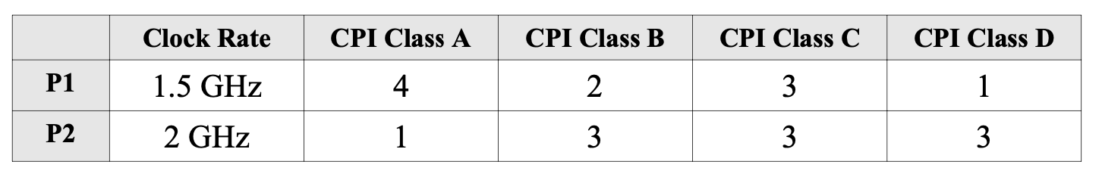

a) Given a program with 106 instructions divided into classes as follows: 10% class A, 20% class B, 50% class C, and 20% class D, which implementation is faster? [10 pts]

Time = (instructions * CPI)/clock rate

Class A = 10% * 106 = 105 instructions

Class B = 20% * 106 = 2(105)

Class C = 50% * 106 = 5*(105)

Class D = 20% * 106 = 2(105)

P1

A = (105 * 4)/(1.5*109) = (2.667 *105) /* 109 = 2.667 *10-4 seconds

B =( 2(105) * 2)/(1.5*109) = (4*105) /(1.5* 109) = 2.667 *10-4 seconds

C =( 5(105) * 3)/(1.5*109) = (15*105) /(1.5* 109) = 10*10-4 seconds

D =( 2(105) * 1)/(1.5*109) = (2*105) /(1.5* 109) = 1.33 *10-4 seconds

Total time = 16.67 *10-4 seconds

P2

A =(105 * 1)/(2*109) = (105) /(2* 109) = 0.5 *10-4 seconds

B =(2(105 )* 3)/(2*109) = 6(105) /(2* 109) = 3 *10-4 seconds

C =(5(105 )* 3)/(2*109) = 15(105) /(2* 109) = 7.5 *10-4 seconds

D =(2(105 )* 3)/(2*109) = 6(105) /(2* 109) = 3 *10-4 seconds

Total time = 14*10-4 seconds

**P2 is the faster time with 14*10-4 seconds**

b) What is the global CPI for each implementation? [5 pts]

CPI = (time * clock rate)/ instructions

CPI for P1 = (16.67 *10-4 seconds * 1.5*109) / 106 = 25.005 *10-1 or 2.5005

CPI for P2 = (14*10-4 seconds * 2*109) / 106 = 28*10-1 or 2.8

15) Compilers can have a profound impact on the performance of an application on a given processor. This problem will explore the impact compilers have on execution time. Must show calculations for credit.

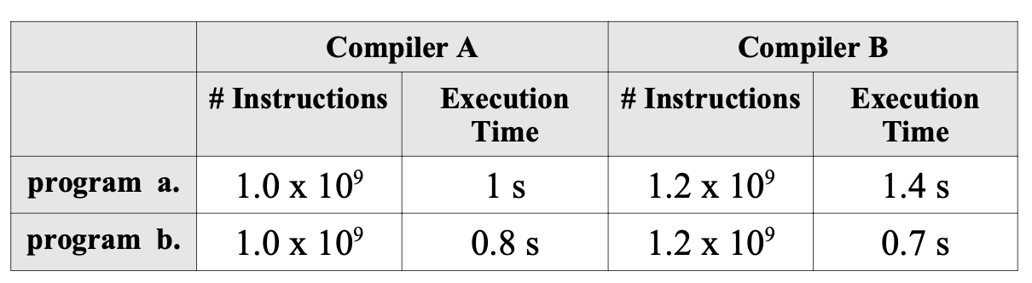

a) For the same program, two different compilers are used. The table above shows the execution time of the two different compiled programs. Find the average CPI for each program given that the processor has a clock cycle time of 1 nano second. [5 pts]

CPI = executiontime / (instructions * clock cycle time)

Program A

Compiler A Average CPI = 1 s / (109 * 10-9)= 1

Compiler B Average CPI= 1.4 s /(1.2* 109 * 10-9) = 1.167

Program B

Compiler A CPI = .8 s/ (109 * 10-9) = .8

Compiler B CPI = .7 s /(1.2* 109 * 10-9) = .583

b) Assume the average CPIs found in a), but that the compiled programs run on two different processors at the same (time?). How much faster is the clock of the processor running compiler A's code versus the clock of the processor running compiler B's code? [5 pts]

Compiler A CPI / Compiler B CPI = A is x times faster than B

Program A

1/1.167 = .857

**Complier A is .857 times faster than Complier B for Program A**

Program B

.8/.583 = 1.372

**Compiler A’s clock time is 1.372 times faster than Compiler B for Program B**